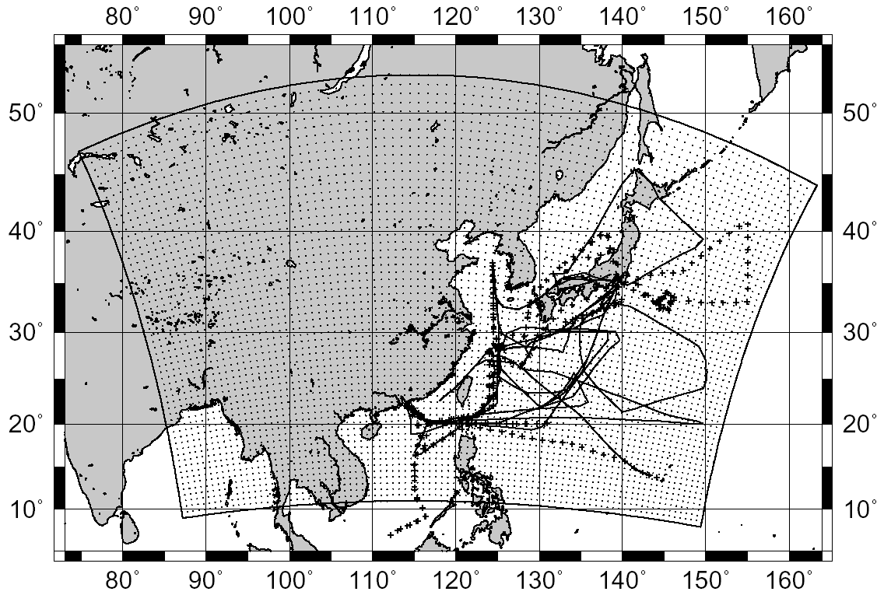

Fig.1 Flight track of each aircraft used in this analysis. Solid line represent DC-8 and Dashed line represent P3B. Our analysis use DC8 #6 - #17 and P3B #8 - #19. Internal box and points represent model boundary and grid point.

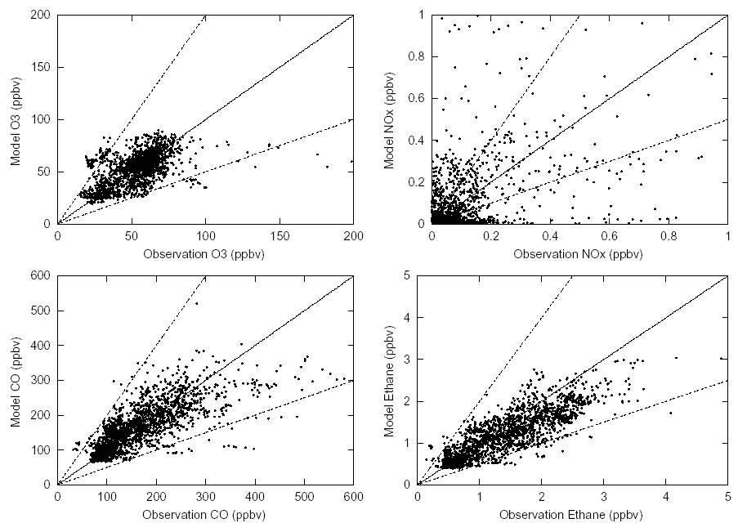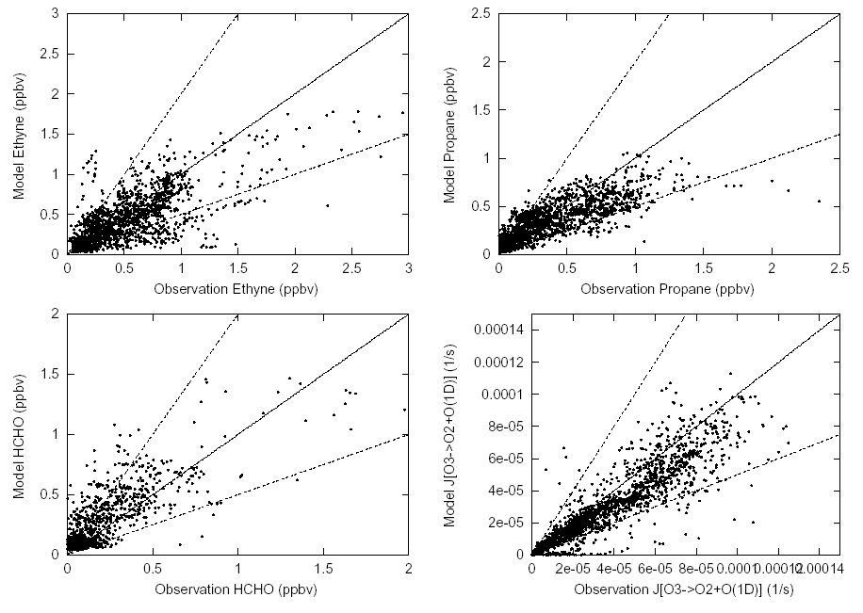
Fig. 2. Scatter plot between model and observed value at flight track every 5-minutes for both aircraft. Broken lines are represent factor 2.
Ozone
NOx
CO
Ethane
Acetylene
Propane
HCHO
J-O(1D)
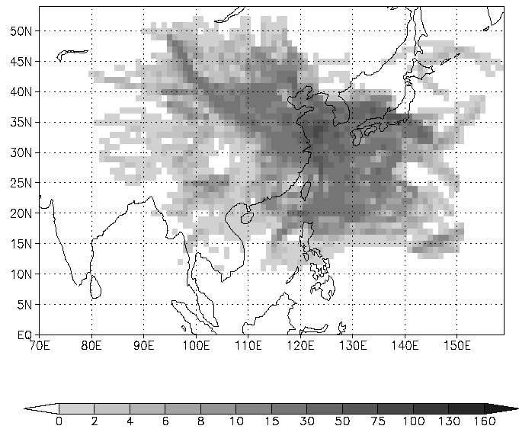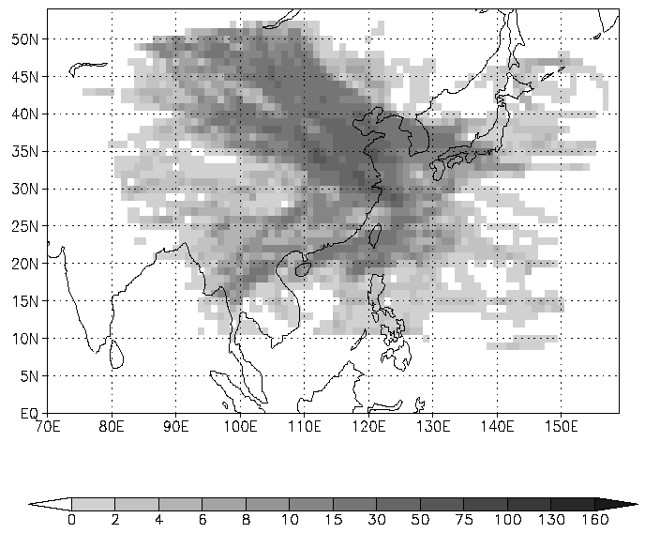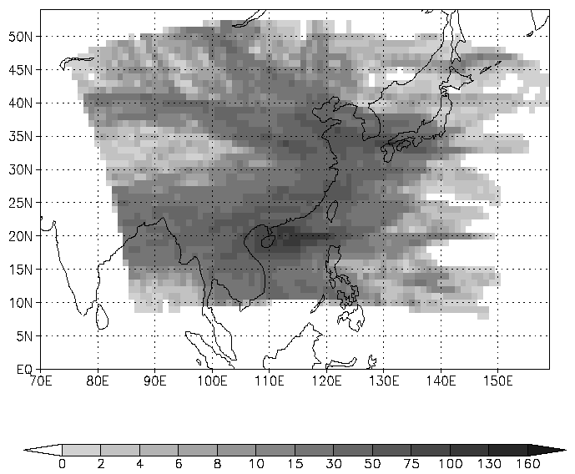
(a) 0 – 1500m (b) 1500 – 3000m (c) over 3000 m
Fig. 3. The total number of the trajectories that passed over each mesh (1° x 1°). Altitude is defined as the height about land-surface.

Fig. 4. Average field of the observed value reconstructed by backward trajectory. (a) CO, (b) Ethane, (c) Acetylene, (d) Propane (ppbv). All trajectories passed within 3000m of surface of each mesh were used.

Fig. 5. Bias between the model and observation value reconstructed by backward trajectory for CO, Ethane, Acetylene and Propane, respectively. Plus values mean over-prediction, minus means under-prediction. All trajectories passed within 3000m of surface of each mesh were used.

Fig. 6. Comparison of the ratio between model and observation by using backward trajectory to redistribute the value on flight track to the map. Ratios for observation and model are regression slope. Background concentration, which is a function of potential temperature, was subtracted for CO and ethane. All trajectories passed within 3000m of surface of each mesh were used.

Fig. 7. Average of the time rate of change of the calculated concentration on the trajectories (ppbv h⁻¹). All trajectories passed within 3000m of surface of each mesh were used.

Fig. 8 Average time rate of the change of the ratio of Propane/Acetylene, Propane/Ethane and Propane/CO (h⁻¹). All trajectories passed within 3000m of surface of each mesh were used.

Fig. 9. Vertical structure of the time-rate of change or the ratio of Propane/Acetylene, Peopane/Ethane and Propane/CO (h⁻¹). These are average of the value on the trajectories between 20°N-30°N.

Fig. 10. Scatter Plot between Observed Propane and Observed Acetylene/CO ratio.

Fig. 11. Scatter plot between Propane and Acetylene both from Observation and Model.
Red point represent Acetylene > 0.3ppbv and Propane/Acetylene ratio > 0.6 within observation data.

Fig. 12. Scatter plot between model and observation for Acetylene and Propane. Red color represents the same airmass in Fig. 11.

Fig. 13. The percentage of the trajectories, which is colored by red in Fig. 11 and 12 against all trajectories (x100 %). High percentage means that most of the airmass passed over that mesh were classified as having small propane/acetylene ratio.

