Regional Chemical Weather Forecasting in Support of Atmospheric Chemistry and Air Quality Studies

G.R.Carmicahel², I. Uno¹, D.G. Streets³, Y.Tang², and Jung-Hun Woo²
1: Research Institute for Applied Mechanics, Kyushu University, Fukuoka, Japan
3: Center for Global and Regional Environmental Research, University of Iowa, Iowa City, Iowa, U.S.A.
2: Argonne National Laboratory, Illinois, U.S.A.

1. INTRODUCTION

Large-scale intensive field experiments play an important role in atmospheric chemistry research, as exemplified by the recent NASA GTE/TRACE-P (Tropospheric Atmospheric Chemistry Experiment Pacific; IGAC/IGBP ACE-Asia (Asian Pacific Regional Aerosol Characterization Experiment; and NOAA ITCT 2K2 (Intercontinental Transport and Chemical Transformation 2002) studies. These experiments involved multiple aircraft, ships, satellite measurements, ground-based observations, and engaged more than 100 scientists. They were designed to characterize atmospheric chemistry and transport in association with features of specific scientific interest (e.g., transport of pollutants in association with post frontal outflow) and to test certain aspects of our understanding. One difficulty in the execution of such experiments lies in the fact that features of interests are usually transient in nature. Flight planning relies on forecasting what features of interest are in the region and where they are expected to be at the time of the flight. Traditionally, flight planning has relied on meteorological forecasts alone. CTMs (Chemical Transport Models) are now being used in forecast-mode to enhance flight planning by enabling the representation of important three-dimensional atmospheric chemical structures (such as dust storm plumes, polluted air masses associated with large cities, and widespread biomass burning events) and how they evolve over time. With this added information, it is hoped that the expensive field-deployed resources (facilities and people) can be employed/utilized more effectively, and science successes maximized. CTM forecasts play the additional important role of providing a contextual representation of the experiment, and facilitate a quick analysis of the field results. The data obtained along the flight tracks for specific experiments (of typical duration of 8 hrs) provide the “real” representation of the atmosphere at those specific points in time and space. The models predict the time evolution and three-dimensional structures within the entire region of operation during the proposed measurement period. When measured and modeled data are viewed together, the context of the observations is elucidated. For example, one can see the sources of the air mass intercepted and measured by the aircraft and where it was headed. In addition, when viewed over the entire field period (typically weeks to months), the combined data set of measured and modeled quantities allows for an assessment of how typical the observed features are (i.e., is the observed feature unusual or do events like it occur with some regularity).

We developed an operational Chemical weather FORecasting System (CFORS) based on a 3D on-line regional scale chemical transport model fully coupled with RAMS (Regional Atmospheric Modeling System [Pielke et al., 1992]) to support atmospheric chemistry field experiments. CFORS was applied in the design and execution of the ACE-Asia and TRACE-P intensive field experiments. In this paper, we present a detailed description of the CFORS chemical transport model and illustrate the performance of CFORS using observations from two Japanese islands. A detailed analysis of the aircraft measurements during ACE-Asia is the subject of another paper (Carmichael et al., 2003). Illustrated examples of the use of CFORS for flight planning are presented in Carmichael et al., [2002a].

2. MODEL DESCRIPTION

An overview of the CFORS modeling system as used in ITCT-2K2 is shown in Figure 1. CFORS is a multi-tracer, on-line, system built within the RAMS mesoscale meteorological model (Pielke et al. ,1992). An important feature of CFORS is that multiple tracers are run on-line in RAMS, so that all the on-line meteorological information such as 3-D winds, boundary-layer turbulence, surface fluxes and precipitation amount are directly used by the tracer model at every time step. As a result, CFORS produces with high time resolution 3-dimensional fields of tracer distributions and major meteorological parameters. CFORS includes a wide variety of tracers to help characterize air masses. These include: 1) important anthropogenic species (SO₂/SO₄, CO, black carbon, organic carbon, fast and slow reacting hydrocarbons, and NO_{x}); 2) species of natural origin (yellow sand, sea salt, radon, volcanic SO₂); and 3) markers for biomass burning (CO, black carbon, and organic carbon). CFORS on-line forecast products consist of gas and aerosol mass distributions, and meteorological parameters. The numerical model domain of CFORS-on-line, is centered at 25°N 115°E with a horizontal grid of 100 by 90 grid points and a resolution of 80 km. In the vertical, the domain is divided into 23 layers, with the top level at 23km.

The CFORS system can be operated both in forecast and hind cast modes. During the TRACE-P intensive observations, CFORS was run in an operational forecasting mode and provided daily forecasts of meteorology and gas/aerosol distributions. A unique element of the operational model was that two separate forecasts were produced each day; one where the RAMS model was initialized by NCEP (National Center for Environmental Prediction/ NOAA; 96 hour forecasting AVN data set; http://www.emc.ncep.noaa.gov/modelinfo/index.html); and the second using JMA (Japan Meteorological Agency; 72 hour forecasting ASIA domain data set; http://ddb.kishou.go.jp/) products. Both NCEP and JMA forecasting results were also used for RAMS nudging calculations. This procedure provided some measure of the forecast variability. For each day the following 72-hr forecasts were provided: 1) CFORS/on-line produced meteorological and tracer fields for both JMA and NCEP initializations; 2) photochemical fields using the RAMS fields to drive STEM-2K1 at 80 km; and 3) same as 2) but for 16 km horizontal resolution. After the field campaigns, the CFORS system was applied in hind cast mode using ECMWF global meteorological data set (6 hour interval with 1°×1° resolution), analyzed weekly SST (sea surface temperature) data, and observed monthly snow-cover information as the boundary conditions for the RAMS calculations. All calculations were performed on Linux clusters and results were made available via the CFORS web manager. The CGI interactive interface can plot 2-D of fields and time-height cross-sections at fixed points according to user’s requests. Quick-look vis5D 3-D animations were also provided. The CFORS web site can be accessed at http://cfors.riam.kyushu-u.ac.jp/~cforsdemo/index.html. Further details regarding the CFORS/on-line are presented in Uno et al., (2002).

The meteorological fields, and those emissions estimated in an on-line manner inside of CFORS, were used to drive the STEM-2K1 comprehensive CTM, which then produced estimated fields of primary and secondary chemical and aerosol constituents. This model is an enhanced version of the STEM model. The important new features in STEM-2K1 include: i) the use of the SAPRC99 chemical mechanism, which consists of 93 species and 225 reactions; ii) the integration of the chemical mechanism using and the implicit second order Rosenbrock method; the calculation of photolysis rates on-line, considering the influences of cloud, aerosol and gas-phase absorptions due to O₃, SO₂ and NO₂, using the NCAR Tropospheric Ultraviolet-Visible (TUV) radiation model; and iv) the extension of the aerosol calculations to include optical information (e.g., extinction) in addition to mass, size and composition.

3. ILLUSTRATIVE RESULTS

Regional scale modeling that combines meteorological calculations, with on-line air mass tracers, emissions and photochemistry provides a powerful analysis framework. The mesoscale meteorological model provides a means to produce dynamic fields with higher space and time resolution than available from global archived products. Furthermore, having in a single data set information on clouds, winds, boundary-layer turbulence measures, information on aerosol and trace gas distributions, and regional emissions, facilitates forecast/planning activities and provides a valuable context for the interpretation of the observations. To illustrate, snap-shots of CFORS forecasts for March 3 and 9, 2001 are shown in Figure 2. Pollution outflow in cold fronts traveling off East Asia are shown. On March 3 an intense low was situated north of Beijing and strong winds behind the front transported pollutants at all levels to the northeast into the center of the low. March 9 outflow in the decaying part of a cold front occurred. Outflow in the warm conveyor belt is seen, but low-layer flows (below 2 km) were typical of winter-monsoon flows, with pollutants from east China transported towards the south. The coloring of the CO-isosurface indicates the relative contribution of biomass burning. The red color indicates that biomass burning dominates the contributions to CO mixing ratios. The spatial distributions (horizontal and vertical) of regions heavily impacted by biomass burning differ from those from fossil fuel combustion.

3.1 How well did the model perform?

Data obtained in these field experiments provide an excellent opportunity to test the capabilities of CTMs to represent important observed features of trace gas distributions in the western Pacific. Comparing calculated values with observed quantities provides a test of the emissions estimates, and the transport and chemical processes represented in the model. To characterize the models abilities and limitations, the model results are compared with the aircraft data. For these comparisons the 5-minute merged data sets for the DC-8 were used. The model was sampled every five minutes along each flight-track for the period when the aircrafts were operating in the western Pacific (March 4 to April 2, 2001). Model results were interpolated to the aircraft location and time (using tri-linear interpolation). The number of parameters calculated in the model that were also observed is large. The analysis discussed above has been done for each of these parameters. A summary of the performance of the model for each of the model-calculated parameters is presented in Table 1 for the DC-8 platform, respectively. For the DC8 data set, the mean values calculated by the model are within +/- 30% of the observed values for all the parameters for measurements below 1 km. Above 1 km, all the modeled mean values are within +/- 30% with the exception of PAN, NO₂, C₂H₄ and SO₂ in the 1-3 km region, and SO₂, NO₂ and NO for altitudes above 3 km. Below 1 km, regression coefficients (R) are greater than ~0.7 for 21 of 31 parameters, and exceed 0.5 for all parameters except NO₂ and NO. In general the regression coefficients decrease with increasing altitude (e.g., ethane value is 0.83 at altitudes below 1 km and 0.72 at altitudes above 3 km). But a few species have their lowest R-values below 1 km (i.e., OH and HO₂). For points above 1 km, some parameters are better predicted in the 1-3 km range than above (as is the case for ozone), while others have their lowest R-values in the 1-3 km range (e.g., CO, SO₂, NO).

The results in Table 1 also provide important insight into our present capabilities to model tropospheric trace species. The meteorological parameters are modeled most accurately, reflecting the large amount of observational data ingested into the reanalysis of the large-scale meteorological fields. The model has significantly less skill in calculating the chemical species; but it is somewhat surprising that the degree of predictability does not clearly separate by reactivity. For example in the boundary layer the predictability for ethane>propane>ozone>ethene> carbon dioxide. These results reflect the complex interactions and interdependencies between emissions and chemical and transport processes, and point out the challenges we face in improving our modeling capabilities.

3.2 The use of forecast products for flight planning

To illustrate how the forecast were used in the field, we present the forecasted biomass-burning tracer (CO) along 20N in Figure 3. Also shown are the observed CO distribution and the observed soluble aerosol K⁺ concentrations (potassium is a good tracer of biomass burning) measured on the P-3. The observed layer of enhanced K⁺ is found in the warm sector outflow at the latitude and altitudes forecasted. Three-dimensional back trajectories for each 5-minute flight segment for all flights were calculated from our 3- dimensional wind fields. These results indicate that the air sampled above ~2 km, was influenced by biomass burning emissions approximately 4 days previously, and that this air was lifted by orographic forcing over the highlands of northern Southeast Asia to nearly 4 km, and then descended to 2-3 km in the leading edge of the surface high pressure system centered of Vietnam. In contrast air below 2 km passed at low altitude over the source regions of eastern China and traveled south over the Ocean in the low-level winter monsoon flow.

3.3 Emissions testing and ozone production

We have also used the results from these experiments to assess ozone production in East Asia. Ozone is emerging as one of the primary air pollution issues in the region. However analysis and design of control strategies is limited by the lack of detailed emissions inventories, and measurements upon which to assess ozone production and to test air pollution models. The TRACE-P experiment has produced a data set that we can use to test our ability to model ozone formation in East Asia (in the springtime). Form this data we have estimated ozone production efficiencies, and found them to be highest in SE Asia outflow and minimum in the Yellow Sea. We estimated the relative importance of NOx and NMHC in ozone production in East Asia. Throughout most of the region during the period of the experiment ozone production was NOx-limited. NMHC limited conditions were identified in the highly industrialized regions of East Asia, where fossil fuel usage dominates. South of ~30-35N, ozone production was found to be NOx-limited, reflecting the high NMHC/NOx ratios due to the large contributions to the emissions from biomass burning, biogenics sources, and biofuel usage in central China and SE Asia.

We have also explored various ways in which measurements made during these experiments can be used in conjunction with regional modeling analysis to evaluate emission estimates for Asia. The first level of evaluation involved comparisons between the modeled values and the aircraft observations. Based on this analysis we conclude that the inventory performs well for the light alkanes, CO, ethylene, SO2, NOx. Furthermore, the model was shown to have skill in predicting important photochemical species such as O3, HCHO, OH, HO2, and HNO3. These results indicate that the emissions inventories are of sufficient quality to support preliminary studies of ozone production. These are important finding in light of the fact that emission estimates for many species (such as speciated NMHCs and BC) for this region have only recently been estimated and are highly uncertain.

A second approach is to classify the aircraft measurements by source region using trajectory analysis. We calculated, using the 3-dimensional RAMS meteorological fields, back-trajectories every 5-minutes along the flight paths, and kept track of when the trajectories passed over specific regions of interest. For emissions-related comparisons, it is useful to limit the analysis to locations along the back-trajectories that are within 2 km of the surface, since these are the air masses most likely to be influenced by the regional emissions. This data can be further classified for specific analysis. For example for studying megacity emissions, the data can be further classified into measurement periods where we were likely to have had influence of emissions from specific megacities. From this analysis we can classify the possibility of influence, and also the time along the back trajectory that the air mass encountered the urban environment. This analysis identified many opportunities to characterize emissions from large cities. For example, air masses influenced by Shanghai emissions were identified more than 150 times, and ~ 100 of these had travel times of less than 1 day. Using this classification of the measurements, we compared observed species distributions, and ratios of species, to those modeled, and to ratios estimated from the emissions inventory.

We used this approach to isolate megacity plumes, and then calculated the ratios of selected species by regressing one species against the other. Regressing only data points of a specific age further refined the analysis. In the case of emission estimates we assume that air masses less than 1-day have the strongest emissions signatures and the least uncertainty in the trajectories. This analysis can be performed using the observational data and repeated for the modeled data. A summary of selected ratios for Shanghai is presented in Table 2. Many of the model derived ratios fall within ~25% of those observed, and only C₂H₆/C₂H₂, HCHO/CO, and NO_{x}/CO fall outside of a factor of 2. The HCHO/CO ratio is influenced more by the photochemical processes than by the ratio in the primary emissions, and is discussed later. The coefficients of determination (r²) are also shown. In most cases the model-based analysis show higher coefficient of determination than the observation-based analysis, reflecting that collectively the model system (emissions, resolution, transport, chemistry, removal) does not represent all of the variability in the atmosphere, and the fact that the classification scheme is based on the modeled winds, which are the same winds used in the forward model simulations.

  - Dust predictions

The prediction of dust storms is another important use of the regional models. During Ace-Asia we sampled dust storms on several occasions. The most significant and famous dust storms during ACE-ASIA period occurred from April 6 to 13th, which was named as “perfect storm” by some researchers. Our model simulation compared with surface weather observation and satellite images for this period is shown in Figure 4. The dust storm began on April 5th in Northwest of China due to a cold air outbreak and corresponding strong surface wind. This dust strong spread to east transporting along with a cold conveyor belt and arrived in the region of Eastern Mongolia - Northeast China on April 7th. During this period, the dust storm was intensified because the cold front kept emitting draft sands along its transport route. This great dust storm was clearly recorded by both of GMS-5 satellite and surface weather observation. Generally the model simulation yields a reasonable dust distribution, and agrees well with the observations in most areas. Only in Northeast Mongolia did the model underestimate the dust wet removing and scavenging processes, and led to over predict dust existences in this area. On April 9th, this dust storm moved to the coast area near Japan Sea and headed northeast. Observed surface wind speed reached 55km/h near the dust storm center. This dust airmass kept moving to east until reached North America 4 days later. At the same time, another dust storm formed in Mongolia also due to strong frontal wind, and moved eastward along the similar route. Some clouds covered the dust regions, which changed the color in the dust-enhanced satellite image. It should be noted that both satellite image and surface weather observation may miss some dust areas, depending on the cloud coverage and the station geographical locations respectively. On April 11th, the dust distribution clearly reflected the cold and warm conveyor belts of a front. Simulated dust distribution agrees well with the observations. The second dust airmass also headed east, but its route is about 10 degree south to the previous dust storm.

Figure 4 shows that simulated dust distributions agree well with the observation taken by satellite and surface weather stations. ACE-ASIA field experiments provided a direct method to quantitatively examine our dust simulations. Figure 5 shows that simulated coarse dusts agree with the observation, but tend to underpredict for some flight segments. We also calculated the aerosol optical extinction coefficients (AOE) for the wavelength 550nm, and compared them to the observation.

4. CLOSURE

Significant advancements have been made in recent years in our ability to measure and model atmospheric chemistry. We are now able to measure at surface sites and on mobile platforms (such as vans, ships and aircraft), with fast response times and wide dynamic range, many of the important primary and secondary atmospheric trace gases and aerosols (e.g., carbon monoxide, ozone, sulfur dioxide, black carbon, etc.), many of the critical photochemical oxidizing agents (such as the OH and HO₂ radicals), the chemical composition of individual particles, and integral optical properties including scattering at low relative humidity (mid-visible wavelength), fine-mode fraction of scattering, wavelength dependence of both sub-micron and coarse scattering, single scattering albedo of both sub-micron and coarse-mode aerosol, and hygroscopicity of both sub-micron and coarse aerosol. Not only is our ability to characterize a fixed atmospheric point in space and time expanding, but the spatial coverage is also expanding through growing capabilities to measure atmospheric constituents remotely using sensors mounted at the surface and in aircraft. Remote sensors mounted on satellites are now providing global coverage in the troposphere for some chemical species (e.g., CO, HCHO). Similar advancements are being made in our ability to measure key physical properties associated with these constituents, including optical properties and radiance fields.

Chemical transport models (CTMs) are designed to describe the fate and transport of atmospheric chemical constituents associated with the gas and aerosol phases. CTMs have advanced to the point where they now specifically follow on the order of one hundred chemical species, interacting through chemical mechanisms involving hundreds of chemical reactions. In addition, the transport aspects of CTMs are now run in close interaction with dynamic meteorological models, with the tendency to have the chemical and dynamical aspects of the models merged into a single computational system. Because of the growing recognition of the role that aerosols play in radiation, meteorology/climate, and health impact areas, CTMs are now including a more detailed description of aerosol dynamics, and calculate size-resolved aerosol composition, radiances, and photolysis rates interactively with the cloud and aerosol fields. Computational power and efficiencies have advanced to the point where CTMs can simulate pollution distributions in an urban air shed with spatial resolution of a few kilometers, or can cover the entire globe with horizontal grid spacing of less than 100 kilometers (less than 1 degree). Contemporary CTMs when applied in prognostic studies are able to provide quantitative information on the distributions of many of the key trace gases and aerosol constituents in the atmosphere. CTMs have become an essential element in atmospheric chemistry studies, including important applications such as providing science-based input into best alternatives for reducing pollution levels in urban environments, and assessments into how we have altered the chemistry of the global environment.

However, quantitative aspects of model-based atmospheric chemistry analyses and forecasts are hampered by the fact that comprehensive CTMs are often poorly constrained due to a variety of reasons including: incomplete emissions information; lack of key measurements to impose initial and boundary conditions; missing science elements; and poorly parameterized processes. Improvements in the analysis capabilities of CTMs require them to be better constrained through the use of observational data. The close integration of observational data is recognized as essential in weather/climate analysis and forecast activities, and this is accomplished by a mature experience/infrastructure in meteorological data assimilation. By data assimilation we are referring to the process by which model predictions utilize measurements to produce an optimal representation of the state of the atmosphere. The community needs to enhance our capabilities to assimilate data into our CTMs if we are going to advance our ability to forecast chemical weather.

5. REFERENCES

Carmichael,G.R., Y. Tang, G. Kurata, I. Uno et al., Regional-scale chemical transport modeling in support of intensive field experiments: Overview and analysis of the TRACE-P Observations, submitted to J. Geophys. Res., 2002a.

Carmichael, G.R., Y. Tang, G. Kurata, I. Uno, D.G. Streets, N. Thongboonchoo, J-H Woo, S. Guttikundi, A. White, T. Wang, D.R. Blake, E. Atlas, A. Fried, B. Potter, M.A. Avery, G.W. Sachse, S.T. Sandholm, Y. Kondo, R.W. Talbot, A. Bandy, D. Thorton, A.D. Clarke1, Evaluating regional emission estimates using the TRACE-P observations, submitted to J. Geophys. Res., 2002b.

Pielke,R.A., W.R.Cotton, R.L.Walko, C.J. Tremback, W.A. Lyons, L.D. Grasso, M.E. Nicholls, M.D.Moran, D.A. Wesley, T.J. Lee and J.H. Copeland, A comprehensive meteorological modeling system -RAMS, Meteorol. Atmos. Phys., 49, 69-91, 1992.

Uno, I., G. R. Carmichael, D. Streets, S. Satake, T. Takemura, J.-H. Woo, M. Uematsu and S. Ohta: Analysis of Surface Black Carbon Distributions during ACE Asia using a Regional Scale Aerosol Model. submitted to J. Geophys. Res., 2002.

Species and Variables  Table 1. Observed and STEM-Simulated Mean Values and Their Correlation Coefficients for TRACE-P DC-8 Flight #6 to #17 (orig) | Below 1km |  |  | 1km to 3km |  |  | Above 3km
 | Observed | Modeled | R | Observed | Modeled | R | Observed | Modeled | R
Wind Speed (m/s) | 8.27 | 7.57 | 0.837 | 11.11 | 10.88 | 0.89 | 31.92 | 31.34 | 0.984
Temperature (K) | 288.346 | 287.502 | 0.988 | 278.309 | 277.418 | 0.993 | 248.722 | 250.088 | 0.993
H₂O (ppmv) | 13992.7 | 14086.3 | 0.98 | 6528.0 | 6997.4 | 0.96 | 1117.44 | 1534.05 | 0.906
CO (ppbv) | 218.76 | 203.45 | 0.728 | 188.3 | 196.0 | 0.514 | 122.41 | 122.73 | 0.614
O₃ (ppbv) | 51.06 | 49.96 | 0.786 | 52.82 | 51.21 | 0.718 | 61.43 | 59.41 | 0.362
Ethane (ppbv) | 1.97 | 1.60 | 0.881 | 1.69 | 1.466 | 0.789 | 0.907 | 0.81 | 0.731
Propane (ppbv) | 0.62 | 0.463 | 0.829 | 0.480 | 0.414 | 0.707 | 0.154 | 0.189 | 0.70
Ethyne (ppbv) | 0.78 | 0.63 | 0.693 | 0.554 | 0.526 | 0.64 | 0.249 | 0.210 | 0.612
Ethene (ppbv) | 0.18 | 0.20 | 0.762 | 0.113 | 0.161 | 0.294 | 0.0335 | 0.0411 | 0.493
SO₂ (ppbv) | 1.55 | 1.04 | 0.694 | 0.677 | 1.049 | 0.278 | 0.192 | 0.103 | 0.66
SO₄ (ppbv) | 1.58 | 1.31 | 0.65 | 0.826 | 1.013 | 0.495 | 0.218 | 0.190 | 0.725
Acetone (ppbv) | 1.26 | 1.40 | 0.587 | 1.205 | 1.315 | 0.394 | 0.967 | 0.861 | 0.367
Acetone -Singh(ppbv) | 0.941 | 1.40 | 0.458 | 0.931 | 1.315 | 0.397 | 0.686 | 0.861 | 0.487
PAN (ppbv) | 0.55 | 0.57 | 0.802 | 0.314 | 0.508 | 0.63 | 0.188 | 0.134 | 0.547
NO₂ (ppbv) | 0.27 | 0.25 | 0.21 | 0.12 | 0.26 | 0.3 | 0.034 | 0.005 | 0.05
NO (ppbv) | 0.035 | 0.041 | 0.443 | 0.0335 | 0.0365 | 0.07 | 0.053 | 0.007 | 0.245
RNO₃ (ppbv)* | 0.046 | 0.059 | 0.836 | 0.0314 | 0.0453 | 0.792 | 0.0116 | 0.0125 | 0.73
RNO₃ (ppbv) | 0.046 | 0.118 | 0.745 | 0.0314 | 0.097 | 0.632 | 0.0116 | 0.024 | 0.653
Methyl Ethyl Ketone* (ppbv) | 0.236 | 0.190 | 0.594 | 0.193 | 0.166 | 0.356 | 0.077 | 0.067 | 0.49
Methyl Ethyl Ketone (ppbv) | 0.236 | 0.356 | 0.366 | 0.193 | 0.333 | 0.228 | 0.077 | 0.122 | 0.497
H₂O₂ (ppbv) | 0.845 | 1.03 | 0.538 | 1.105 | 1.091 | 0.534 | 0.433 | 0.464 | 0.52
Formaldehyde (ppbv)* | 0.596 | 0.591 | 0.675 | 0.328 | 0.448 | 0.42 | 0.097 | 0.120 | 0.606
Formaldehyde (ppbv) | 0.596 | 0.711 | 0.721 | 0.328 | 0.557 | 0.352 | 0.097 | 0.149 | 0.583
Acetaldehyde-Singh (ppbv) | 0.480 | 0.668 | 0.54 | 0.315 | 0.691 | 0.277 | 0.141 | 0.336 | 0.609
OH (pptv) | 0.095 | 0.082 | 0.577 | 0.0899 | 0.0968 | 0.761 | 0.104 | 0.121 | 0.602
HO₂ (pptv) | 9.30 | 10.04 | 0.64 | 9.67 | 12.15 | 0.864 | 7.41 | 11.16 | 0.794
Benzene + Toluene (ppbv) | 0.330 | 0.190 | 0.633 | 0.184 | 0.156 | 0.495 | 0.053 | 0.044 | 0.641
BC (ug/std m3) | 0.84 | 0.67 | 0.65 | 0.836 | 0.558 | 0.22 | 0.257 | 0.158 | 0.34
AOE @550nm (/km) | 0.0615 | 0.0706 | 0.63 | 0.0389 | 0.0511 | 0.345 | 6.83×10⁻³ | 8.32×10⁻³ | 0.574
J[NO₂] (1/s) | 0.0055 | 0.0039 | 0.741 | 0.0082 | 0.0067 | 0.74 | 0.0116 | 0.0106 | 0.72
J[O₃→O₂+O¹D] (1/s) | 1.95×10⁻⁵ | 1.19×10⁻⁵ | 0.839 | 2.78×10⁻⁵ | 1.93×10⁻⁵ | 0.86 | 4.15×10⁻⁵ | 3.22×10⁻⁵ | 0.933

Modeled results is from the simulation without biogenic emissions.
Table 2. Estimated ratios of select species for data points identified as Shanghai plumes for air mass ages less than 1 day. Results determined from calculations using base emissions and for doubled domestic sector emissions are shown. Ratios determined from the base-emissions are also presented.

 | Observed | Modeled | 2* Domestic | Emissions (base-case)
BC/CO | 0.011 (0.80) | 0.010 (0.98) | 0.012 (0.98) | .008
BC/SO₂ | 0.46 (0.90) | 0.38 (0.52) | 0.55 (0.61) | .08
HCHO/CO | 0.011 (0.70) | 0.006 (0.80) |  | 0.002
C₂H₆/CO | 0.004 (0.91) | 0.006 (0.96) |  | 0.004
C₂H₆/C₂H₂ | 0.39 (0.62) | 1.14 (0.96) | 1.04 (0.98) | 0.66
C₂H₆/C₂H₄ | 0.96 (0.60) | 1.32 (0.53) |  | 0.33
SO_{x}/C₂H₂ | 3.71 (0.77) | 5.69 (0.76) | 3.64 (0.77) | 17.6
NO_{y}/SO_{x} | 0.35 (0.92) | 0.88 (0.91) | 0.85 (0.91) | 1.0
C₃H₈/CO | 0.0027(0.65) | 0.0023 (0.84) | 0.31 (0.89) | 0.005
C₂H₂/CO | 0.0076 (0.76) | 0.0051 (0.88) | 0.0067 (0.92) | 0.0063
C₂H₆/C₃H₈ | 1.19 (0.85) | 2.51 (0.97) | 2.23 (0.98) | 0.82

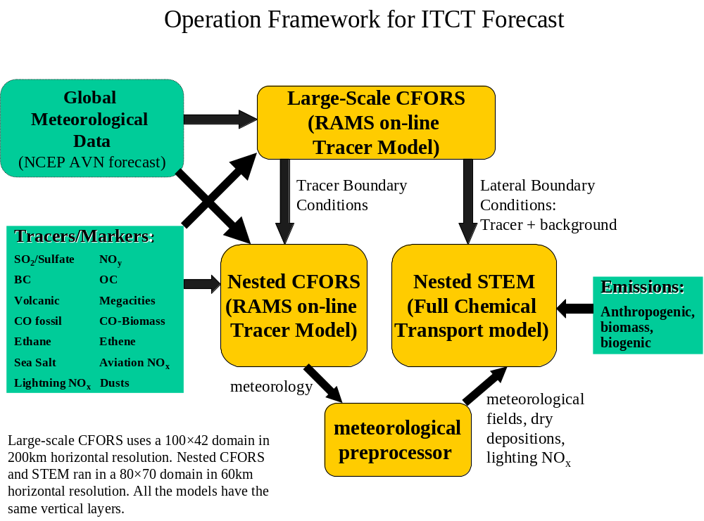
Figure 1. Schematic of the modeling framework used in our ITCT calculations.
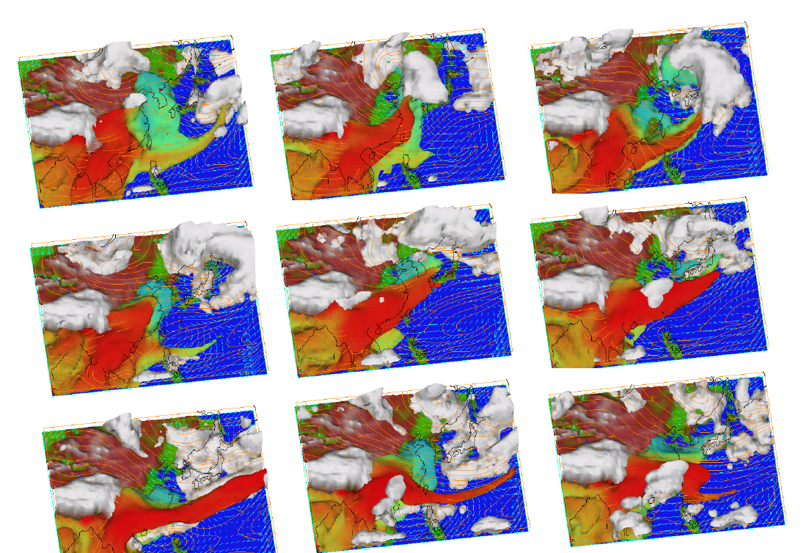

Figure 2. Forecasts of pollution outflow during the frontal events of March 2 (top left) through March 10 (lower right). Shown are clouds (white), BC iso-surface (>1ug/m3) colored by % due to biomass burning (red > 50%), 3 km streamlines (orange), wind vectors at 600 m (blue) at 6 GMT.
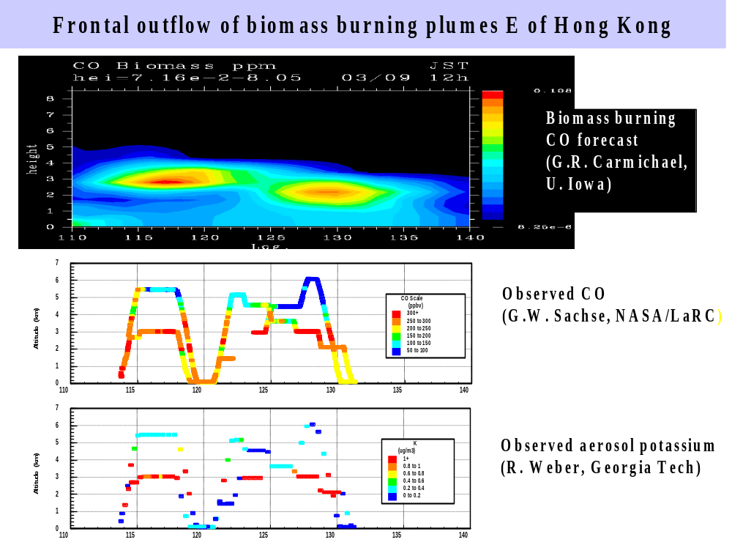
Figure 3. Forecast of CO due to biomass burning along 20N at 3 GMT (12 Japan Standard Time – JST) on March 9 (top). Observed CO and aerosol potassium are also shown. Potassium provides a good tracer for biomass burning.
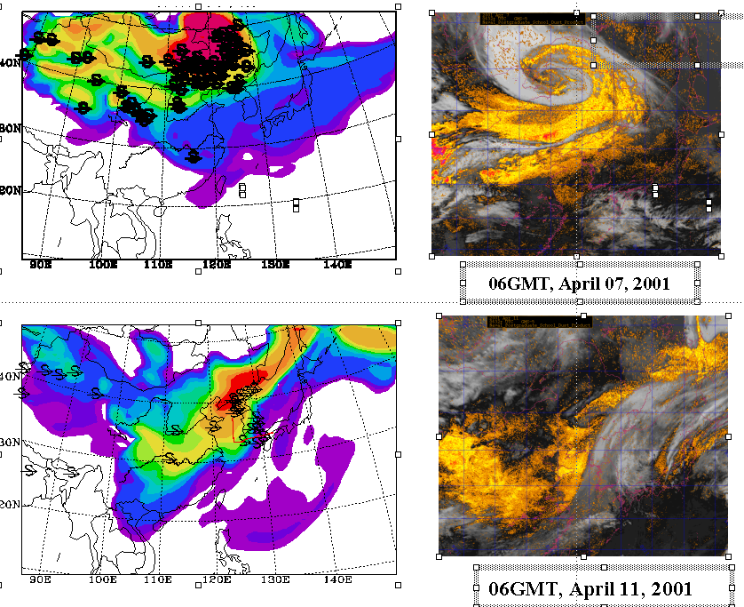
Figure 4. Dust storms shown by the model simulation, surface synoptic observation, and GMS-5 satellite images (dust enhanced) at 06GMT (about 14:00 local time) of April 7 and 11. The model results (left plates) are averaged from the model layers below 3km, and dust symbols are plotted in the station locations where dust weathers were reported at those times. The path (red line) of C130 flight 7 is shown on plot C.

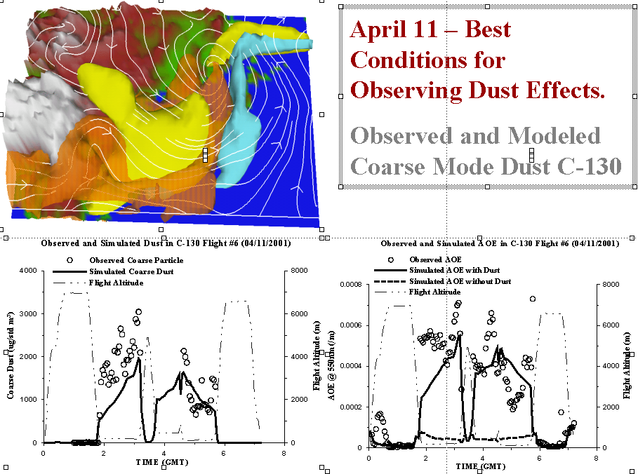

Figure 5. April 11, 2001 is an excellent example of where the C-130 flying in the Yellow Sea, encountered dust mixed with pollution. Model 3-d structure of dust (Yellow), BC (Brown) and Sulfate (Blue) are shown by isosurfaces. Observed and predicted coarse mode-dust and aerosol optical depth along the C130 flight path are also shown.

